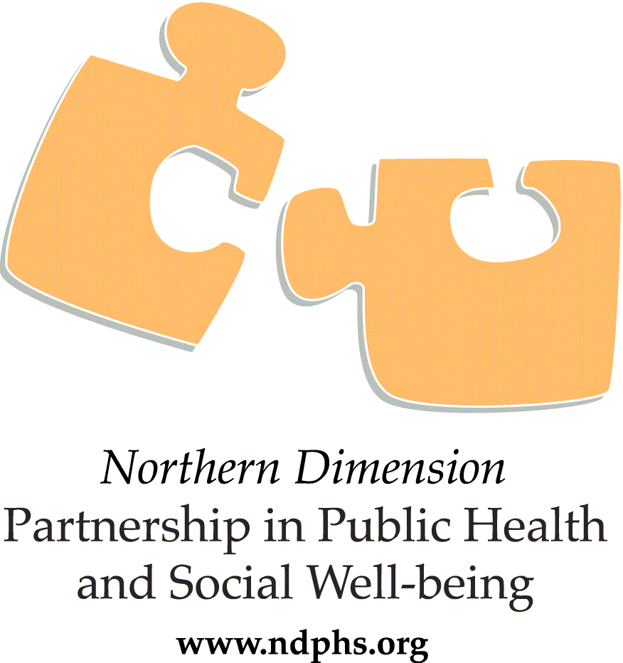

INTERNSHIP PROGRAMME ANNOUNCEMENT

The Northern Dimension Partnership in Public Health and Social Well-being (NDPHS) Secretariat in Stockholm, Sweden is looking for motivated trainees to join the team to gain practical knowledge and professional experience related to the NDPHS activities.
WHAT’S IN IT FOR YOU?
The NDPHS Internship Program offers you an opportunity to round out your academic career with a hands-on experience in an international environment. The intent is that you will learn while contributing to the NDPHS work. The internship program allows you to bring innovative ideas, latest research experience and new perspectives into the NDPHS work and improve your skills while working in a professional environment. In addition, it is a way to enhance your CV with practical work experience.
It is expected that your educational background is related to the activities of the NDPHS. Read more about the NDPHS on the Partnership’s website at www.ndphs.org.
The Internship Program usually lasts for 6 months and is a full-time (40 hours per week) assignment. For the part-time internship minimum 20 hours of commitment per week is required.
You will mainly assist in the daily work of the staff member under whose responsibility he or she is placed. Daily responsibilities will depend on your educational background and experience as well as the internship period.
WHO CAN APPLY?
To be eligible for an Internship you must be a recent university graduate in a field related to the NDPHS activities. Although completed university studies are considered an advantage, applications from students who are currently enrolled in a Bachelor's or Master's degree program and maintaining the student status throughout the internship, will be considered as well.
We are seeking candidates with a background in:
- Thematic fields such as Public Health, Social Wellbeing, Environmental Health, Social Sciences, Political Science, International Relations.
- Corporate Support Services fields such as Public Administration, Information Technology, Communications etc.
Only citizens of the NDPHS Partner Countries are eligible.
EQUAL OPPORTUNITIES
We value diversity in our workplace, and encourage all qualified individuals with diverse professional and academic backgrounds to apply.
We apply equal opportunities and accept applications without distinction on the grounds such as age, race, political, philosophical or religious conviction, sex or sexual orientation and regardless of disabilities, marital status or family situation.
There is no age limit. The NDPHS internship programme does not exclude those who, in the framework of lifelong learning, have recently obtained or are in the process of obtaining a university degree and are at the beginning of a new professional career.
The NDPHS internship programme is not connected with employment opportunities.
LANGUAGES
The successful candidate is expected to be highly proficient in spoken and written English which is the working language of the NDPHS.
terms and Conditions
The place of the internship is Stockholm, Sweden.
The NDPHS Internship programme offers a modest monthly scholarship grant up to 10,000 SEK for the full-time internship to nationals of the NDPHS Partner Countries and pays a travel allowance to compensate the expenses incurred at the beginning and at the end of the traineeship from the place of residence.
Visa, Housing and Health Insurance
You are responsible for taking care of formalities with the Swedish authorities regarding your stay in Sweden including visa requirements. You are required to have a valid health insurance coverage during your stay in Sweden.
Housing arrangements are also your responsibility. The NDPHS Secretariat can assist you with information on accommodation in Stockholm.
The fundamental conditions of NDPHS internship are set out in the Internship Handbook.
How to apply?
Please send a motivation letter that summarizes
- your motivation, educational background, professional skills and expertise
- states your preferred starting time and length of internship
- lists 1-3 references
together with your CV in English in Europass format to secretariat@ndphs.org.
The deadline for application is 25 September 2018 23:59 CEST. The email subject line should be written as “INTERN”.
Please note that applications received after the deadline will not be considered.
Only short-listed candidates will be contacted.
A reserve list of candidates may be drawn up by NDPHS Secretariat following the interviews and used should additional internship opportunities arise. The reserve list will be valid for 12 months after the closure of the selection procedure.
The Selection process
Successful candidates will be selected based on their education, experience and motivation. You are expected to reply within 7 working days from the receipt of the offer.
If an application is unsuccessful you may re-apply in the future.
Questions regarding the application can be submitted to the NDPHS Secretariat at secretariat@ndphs.org.

